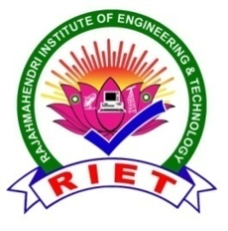 | 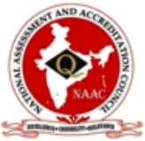  RAJAMAHENDRI  INSTITUTE OF ENGINEERING & TECHNOLOGY  (Approved by AICTE, New Delhi, Affiliated to JNTUK, Kakinada, Accredited BY NAAC)  BHOOPALAPATNAM, RAJAMAHENDRAVARAM, E.G. Dist., AP, 533107.  eMail: office@rietrjy.co.in Website: www.rietrjy.co.in Ph: +91 91212 14413

Report on Student Attributes Facilitated by the Institution
Institute identifies the attributes of admitted students from different backgrounds in various programs. Initially, some attributes of the student can be observed as academic category, cultural, social, and health, economical attributes. During the tenure of the program remaining attributes can identify.
Some attributes are as follows
Database of the Student: At the time of joining, the institution collects the student details of educational background, schooling, and Gender and the Head of the Department allocates to the students for their overall department,
Economic attributes of the Student:Local students can join in large numbers in this institution as socially well as economic background. The financial assistance is provided by various government and private organizations, such as SC, ST, BC and minority scholarships.
Social Attributes:The institution provides a pleasant environment by treating equal status to all students, and the principle of equal justice is followed strictly without any prejudice or discrimination. The institution has established committees like a Code of Conduct, Anti-Ragging committee etc., to monitor, control and manage as and when needed.
Academic Attribute:Slow learners can be identified by the strategic mechanism of the institution and advanced learners are also identified in the academic performance of students. The tutorial classes / Remedial classes, proving handoffs, study material, and counselling to improve their academic performance. Advance learners encourage to participate in seminars/workshops hackathons and competitive exams.
Gender Attributes:As per the saying “Gos reside where women are respected”, the college provides the best facilities and amenities like Waiting Halls in every department. Physical Directors and Wardens are provided to the girl's hostel to monitor and manage the issues related to women.
Personal and Performance attributes:The training and Placement Cell trains students in personality development and technical skills from the first year by adding special hours to the regular academic plan in the entire four-year syllabus.
Health and Fitness Attributes:To improve the fitness of the students for their holistic development, a Gymnasium is provided. The NSS unit creates awareness about social service and self-discipline among the students with learning. The Institution has a residential doctor with nurses to handle health issues.
Linguistic Attributes:Some of the students from a village background, who came from Telgu medium usually face a bit of difficulty in understanding the subjects in English. Such students are given special attention to developing their English language skills both in spoken and written aspects.
The Institution believes in developing the students in all dimensions and finds the case of managing and classifying them through their attributes in each dimension.

IQAC Coordinator Principal

